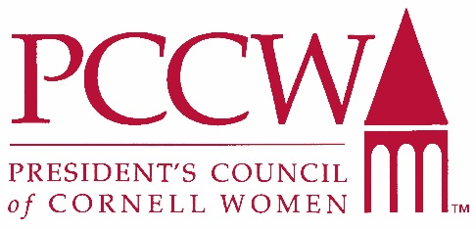

Affinito-Stewart Grants 2019
Purpose

The President’s Council of Cornell Women established the PCCW Affinito-Stewart Grants to assist the university in its efforts to increase the number of women in tenured faculty positions.

PCCW's primary goals include:

- Expanding the role of women in Cornell’s decision-making groups
- Advising the president on issues important to Cornell women
- Attracting outstanding women students, faculty, and staff to Cornell, and enhancing their leadership opportunities
- Engaging leading alumnae by strengthening their ties to each other and to Cornell
- Offering guidance and role models for Cornell women
- Providing financial support for PCCW initiatives and others that help Cornell women

The Affinito-Stewart Grants program was established in 1990 and began awarding grants in 1992 to support pre-tenure Cornell women faculty. The funds provide “seed money” to enable these women to complete research already underway or initiate new research projects that will provide the evidence of scholarship necessary for successful tenure submission. It is the goal of the PCCW Grants Committee to reach as many Cornell women as possible by awarding grants across all disciplines and schools rather than focusing on specific areas, and by awarding many small grants rather than a few larger grants. All PCCW grants are made to advance women at Cornell while addressing the university's priorities.

Affinito-Stewart Grants are intended to lead to:

- Major funding from foundations or government sources;
- Publication of books and/or articles in respected scholarly journals; or
- Other evidence of scholarship appropriate to a specific discipline.

Grant recipients receive funds as transfers to their university accounts at the beginning of the fiscal year following the award. The funds must be used by the end of that fiscal year.

Grant recipients are invited to meet PCCW members at its annual meeting in the fiscal year during which their grants are received.

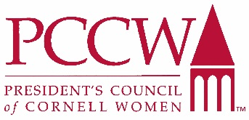

Affinito-Stewart Grants 2019

Fact Sheet

PRIMARY PURPOSE
Increase Cornell's retention of women faculty. PCCW annually recognizes women with awards of up to $10,000 for research and other projects. To date, PCCW has awarded more than $1,330,000 to 257 women at Cornell.

WHO IS ELIGIBLE?
Cornell associate or assistant women professors who will submit materials for tenure June 2020 or later. Applicants may have previously applied to the Affinito-Stewart grant program.

WHAT CAN THE MONEY BE USED FOR? HOW DO I OBTAIN THE FUNDS?
Application may be made to support research on any subject. If research includes human subjects, funding is contingent upon approval by the University Committee on Human Subjects. The recipient must establish a "current restricted" account within her department to which funds can be transferred from the PCCW grants account. A personal check will not be issued. The grants normally do not cover equipment or the cost of conference fees, but with special justification such requests may be considered. Meals are not covered. Funds will be available for expenditure after July 1, 2019
and must be used by June 30, 2020.

WHAT IS INCLUDED IN THE APPLICATION PROCESS?
Proposal Narrative: Includes objective; research design; impact; effect on tenure prospects and research career; contribution to field; work timeline.
Additional Pages: Application cover page, budget, supporting documents, and letters of reference.

WHO WILL READ MY PROPOSAL?
- The PCCW Affinito-Stewart Grants Subcommittee assembles a group of your suggested Cornell faculty to do a first review of your application. Although we encourage you to match the reviewer with your discipline, faculty reviewers reading your grant are not required to work in your particular field.
- Members of the PCCW Affinito-Stewart Grants Subcommittee might represent the fields of discipline from which applications are submitted, as well as other fields. Committee members will do a final review of the applications. Recommendations for grant funding, based on the initial faculty reviews and on the subcommittee reviews, are made to the PCCW Steering Committee for final approval.

WHAT IF MY PROJECT REQUIRES MUCH MORE THAN THE MAXIMUM FUNDING?
Find one component of your research that could be completed within PCCW’s funding limit of $10,000. Write an outline of the whole project, but stress in your proposal that you request funding for just one specific part. Since funding is awarded based on feasibility and effective use of the funds, this will help the reviewers evaluate your proposal.

IF FUNDED, WHAT ARE MY OBLIGATIONS?
Complete the project as described in the time described. Follow all Cornell policies and procedures with respect to purchases for your research and/or reimbursement of your research-related expenses. All equipment purchased by this grant belongs to Cornell University. Funds must be used by June 30, 2020.

Affinito-Stewart Grants 2019

Application Instructions

Invited Applicants: Cornell associate or assistant women professors who will submit materials for tenure June 2020 or later. Applicants may have previously applied to the Affinito-Stewart grant program.
Subject Area: Application may be made to support research on any subject. If research includes human subjects, funding is contingent upon approval by the University Committee on Human Subjects.
Funded Account: The recipient must establish a "temporarily restricted" account within her department to which funds can be transferred from the PCCW grants account. A personal check will not be issued.
Award Amount: Up to $10,000
Criteria: Scholarly merit, originality and significance
- Research design
- Clarity of writing
- Feasibility
- Appropriateness of budget
- Importance and relevance to achieving tenure
Materials: One (1) pdf document including each of the application materials specified below
Format: Times Roman 12 pt., double-spaced, 1" margins
Submission Deadline: February 8, 2019
Announcements: May 2019
Submit electronically to: pccw@cornell.edu
Decision Date: May 2019
Funding Date: Funds are not available for disbursement until July 1, 2019 and must be used within one year of grant approval (no later than June 30, 2020). Extensions will only be approved for extenuating circumstances. All requests for deferral of funds must be in writing and sent to pccw@cornell.edu.

Required Materials

Please submit all materials as one pdf document.

- Cover Page: Complete attached form.
- Proposal Narrative: Maximum length: 3-4 single-sided pages, including:
- Statement of objective
- Research design, including measures, criteria, availability of subjects, and indication of academic progress to this point
- Statement of the impact this grant would have on your project
- Statement of how this project/request would contribute to your tenure prospects and further your research career
- Statement of how this project would contribute to your field
- Schedule for planned work
- One-Page Budget: Please use attached budget form to include a page with appropriate budget justifications and explanation of amount requested. The Affinito-Stewart Grants do not normally cover equipment or the cost of conference fees, but with special justification such requests may be considered. Individual meals are not covered.

- Supporting Documents: Statement about other committed and potential funding sources. Include name of award agency, amount, and award duration (start and end). If there is no additional funding, please indicate "no additional funding."
Curriculum vitae or resume with full list of publications.
One letter of recommendation from a senior faculty member at Cornell University is required; a second letter is optional and may come from any professional in your field.

For more information, please contact pccw@cornell.edu.

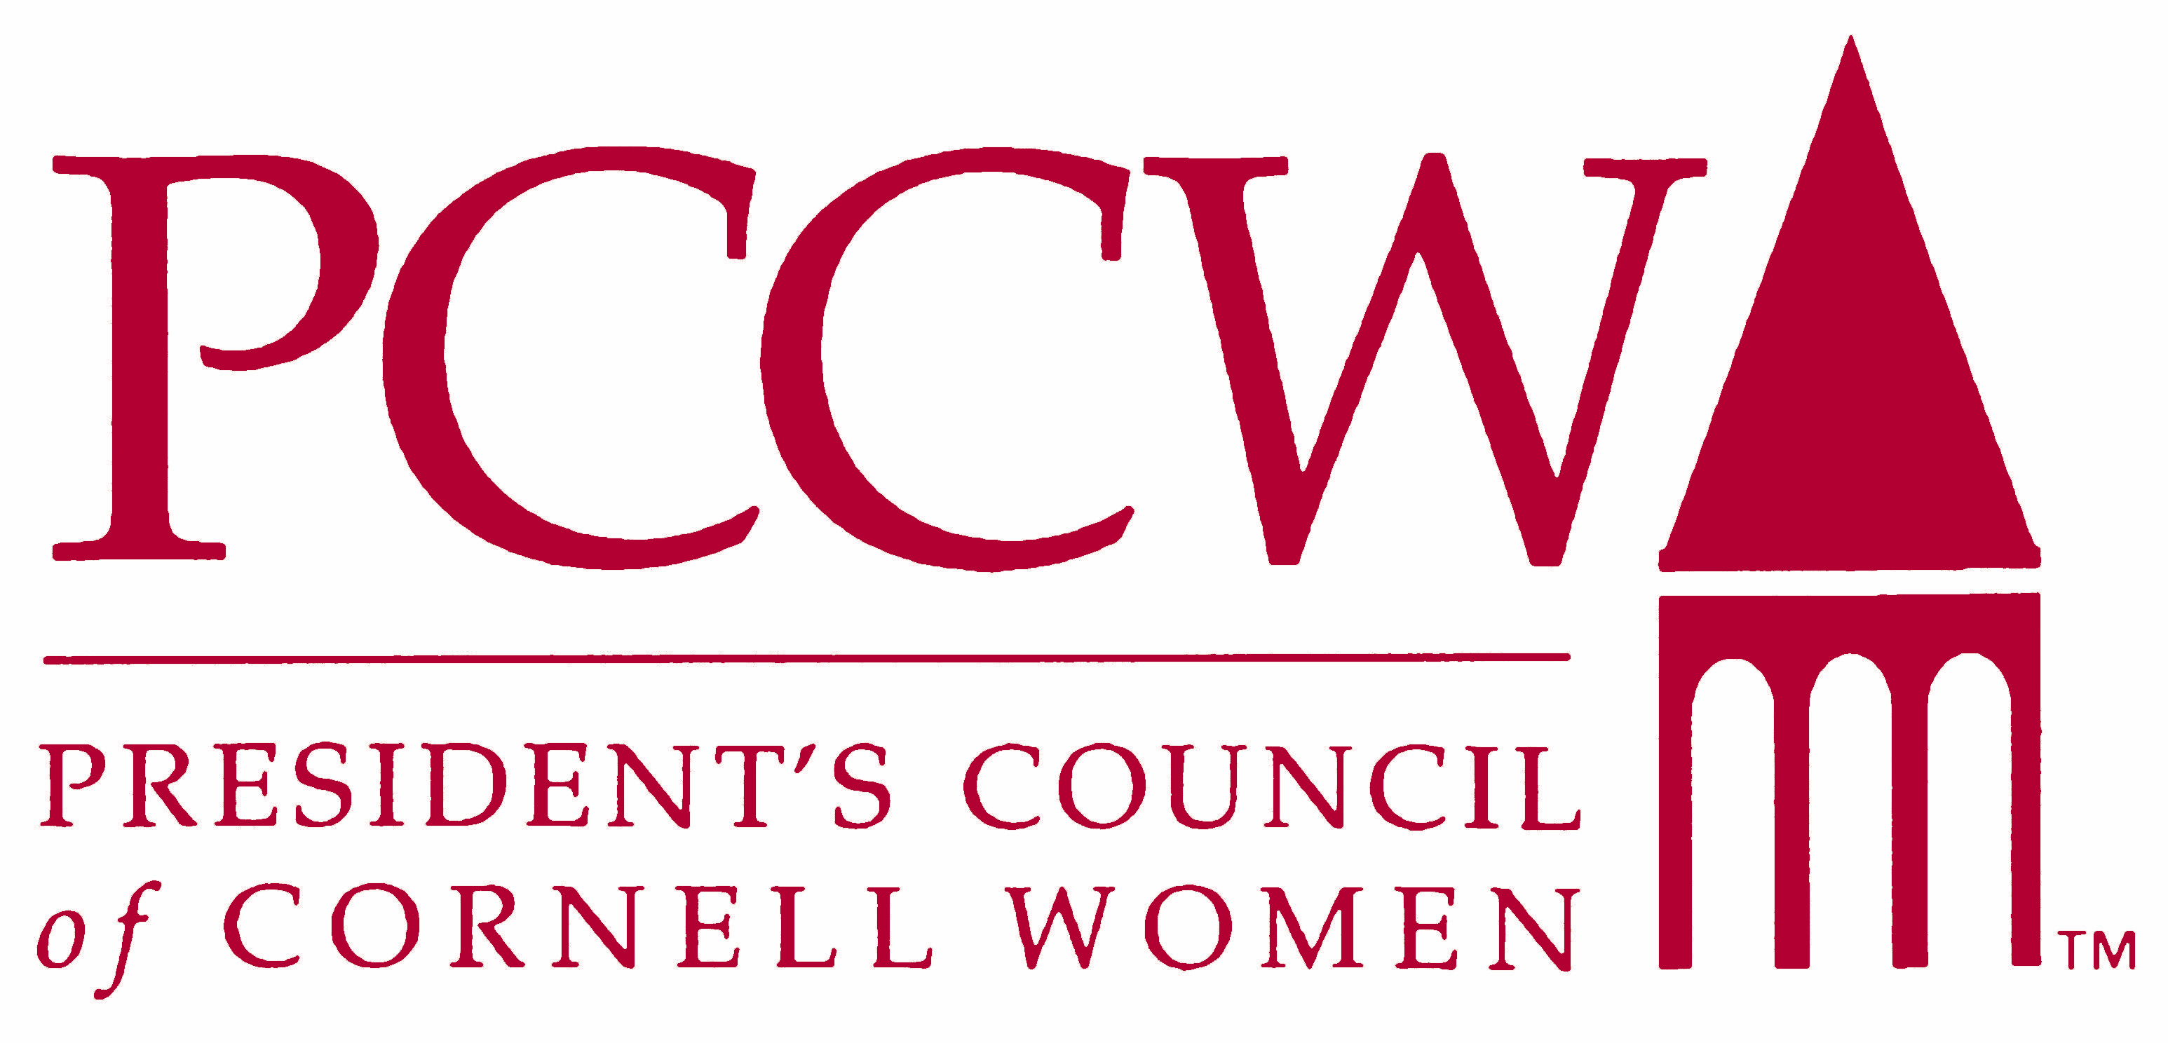
President’s Council of Cornell Women
2019 Affinito-Stewart Grants
APPLICATION COVER PAGE
Submission Deadline: February 8, 2019
Announcements: May 2019

Proposal Title:

Submitted By:
Associate Professor Assistant Professor

Total Funding Requested:
Department:

Dept. Chair

College/Unit:

Tenure Submit Date:
(approximate date you expect to submit tenure documents to your department)

Area of Research:
- Humanities
- Sciences
  - Physical
  - Biological
  - Medical
- Social Sciences
- Creative Arts
- Other (explain)

Please provide the names of two (2) faculty members—preferably within your discipline, but not your department chair—who will serve as reviewers of your proposal. Please notify them that we will contact them to review your application.

1.
2.

Your Work Address:

Work Phone:
E-Mail Address:
Social Media profiles (Twitter, Facebook, LinkedIn, Instagram, etc.):_____________________
____________________________________________________________________________
Date Submitted:

2019 PCCW Affinito-Stewart Grants

SUMMARY PROPOSAL BUDGET

GRANT APPLICANT |  |  |  |  |  |  | TOTAL $ REQUESTED
TITLE OF PROPOSAL |  |  |  |  |  |  | DURATION (months)
DEPARTMENT and COLLEGE |  |  |  |  |  |  | FUNDS REQUESTED  (do not use shaded cells)
A. PERSONNEL (Grants may not be used for faculty salaries.) |  |  |  |  |  |  | Subtotals |  | Totals
1. ( ) POST DOCTORAL ASSOCIATES
2. ( ) GRADUATE STUDENTS
3. ( ) UNDERGRADUATE STUDENTS
4. ( ) OTHER (list individually on Budget Justification Page)

TOTAL SALARIES AND WAGES

B. DIRECT COSTS
- MATERIALS AND SUPPLIES
- PUBLICATION/DOCUMENTATION
- CONSULTANT SERVICES
- COMPUTER SERVICES
- OTHER

TOTAL DIRECT COSTS

C. EQUIPMENT (List item and dollar amount for each item exceeding $250.)

TOTAL EQUIPMENT

D. TRAVEL (domestic or foreign)

1. TRANSPORTATION (Provide breakdown on additional page)

2. LODGING (excluding meals)
3. OTHER

TOTAL TRAVEL
FOR PCCW USE ONLY: | Award No. | Total Requested | Funds Granted |  |  | Date of Rate Sheet |  | Initials (PCCW)

